UNIT 1
LESSON 8 – THE FAMILY PHOTO

- 1 Look at the picture. Read the sentences.
Prouči sliku. Pročitaj rečenice.

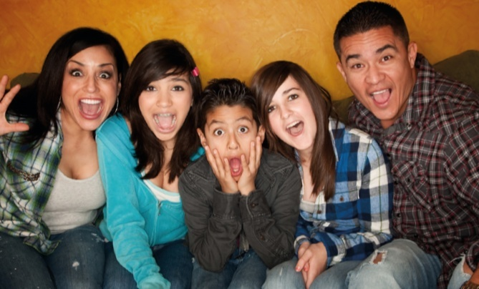

My name iz Xavi. This is my family.
Moje ime je Xavi. Ovo je moja obitelj.

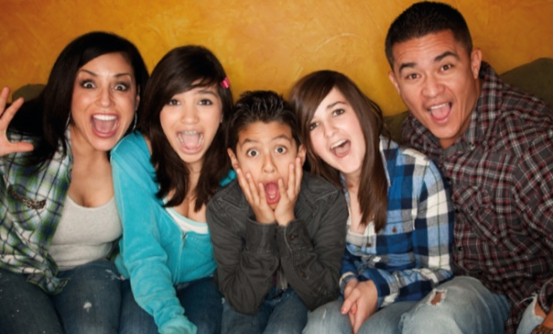
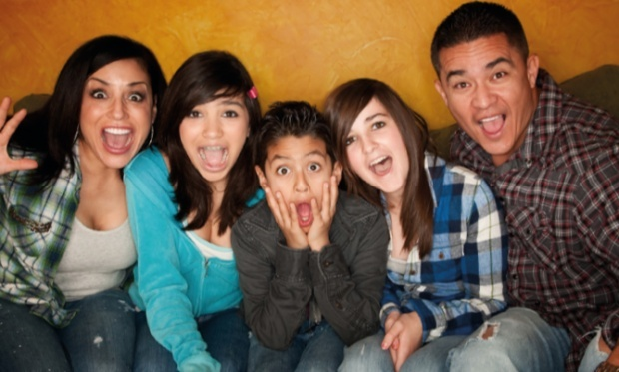

I’m in the middle. This is my mum.
Ja sam u sredini. Ovo je moja mama.

These are my two sisters. This is my dad.
Ovo su moje dvije sestre. Ovo je moj tata.


11

We are happy. I’m 11.
Sretni smo. Imam 11 godina.

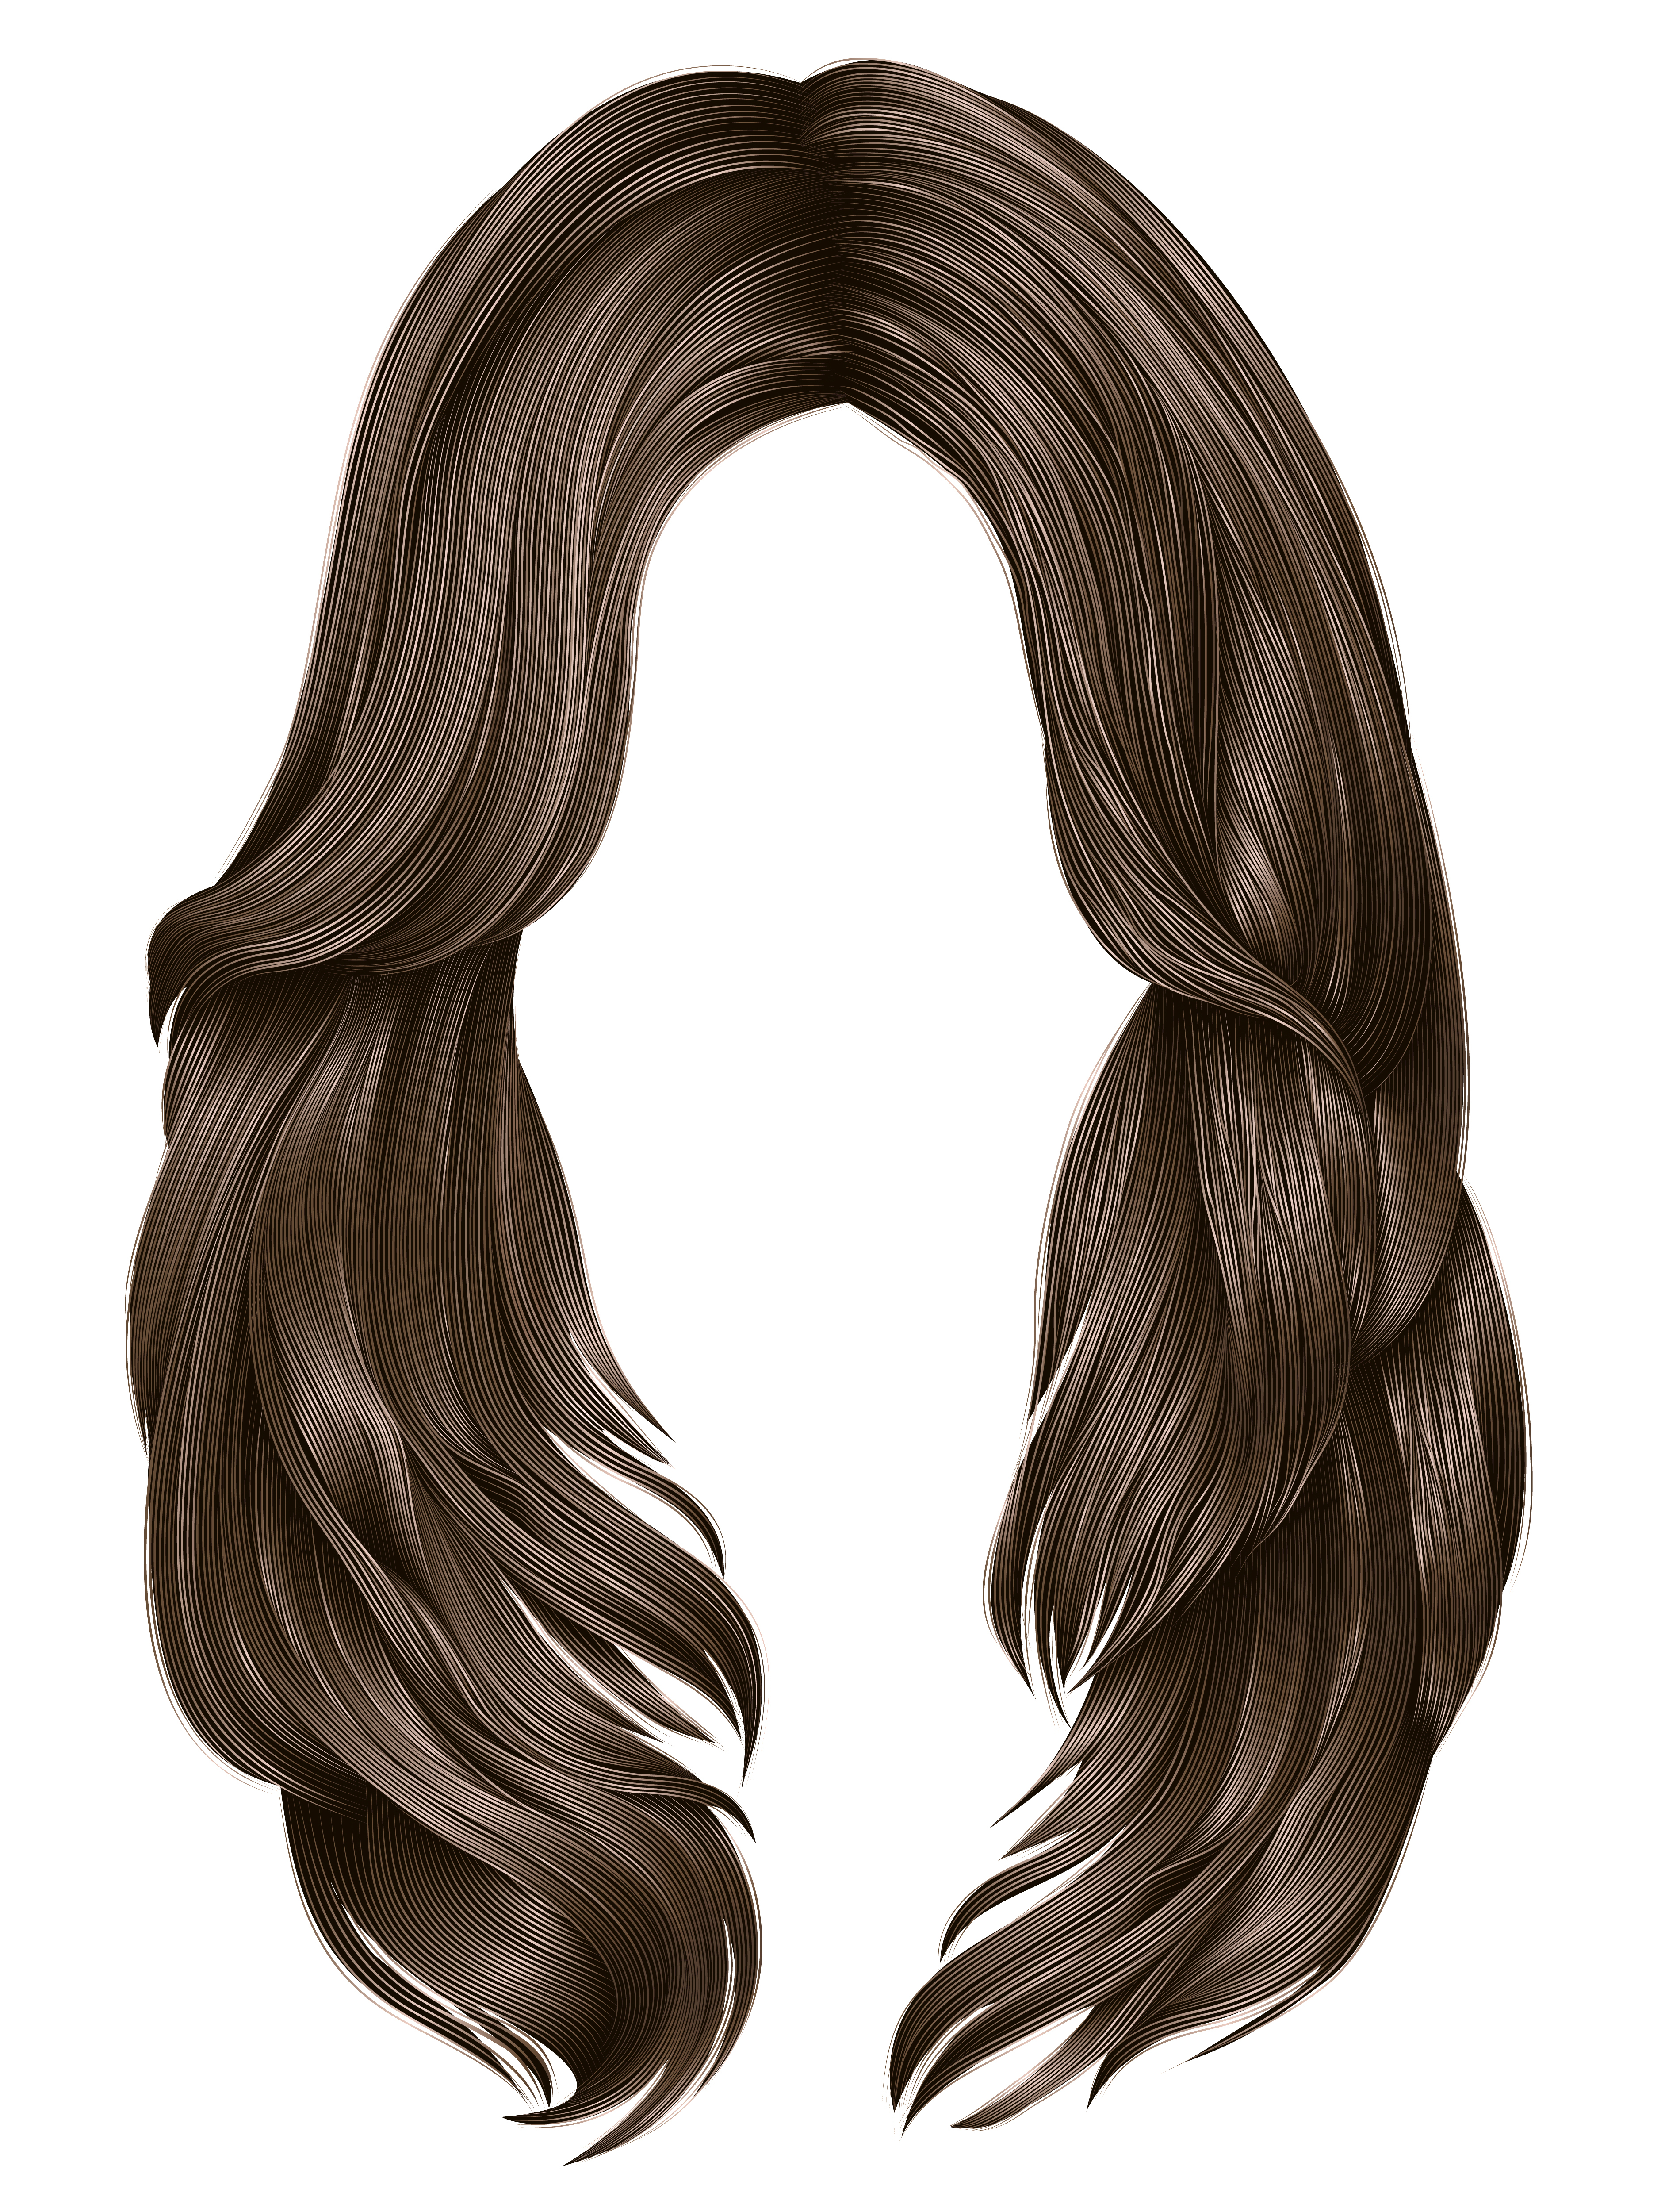
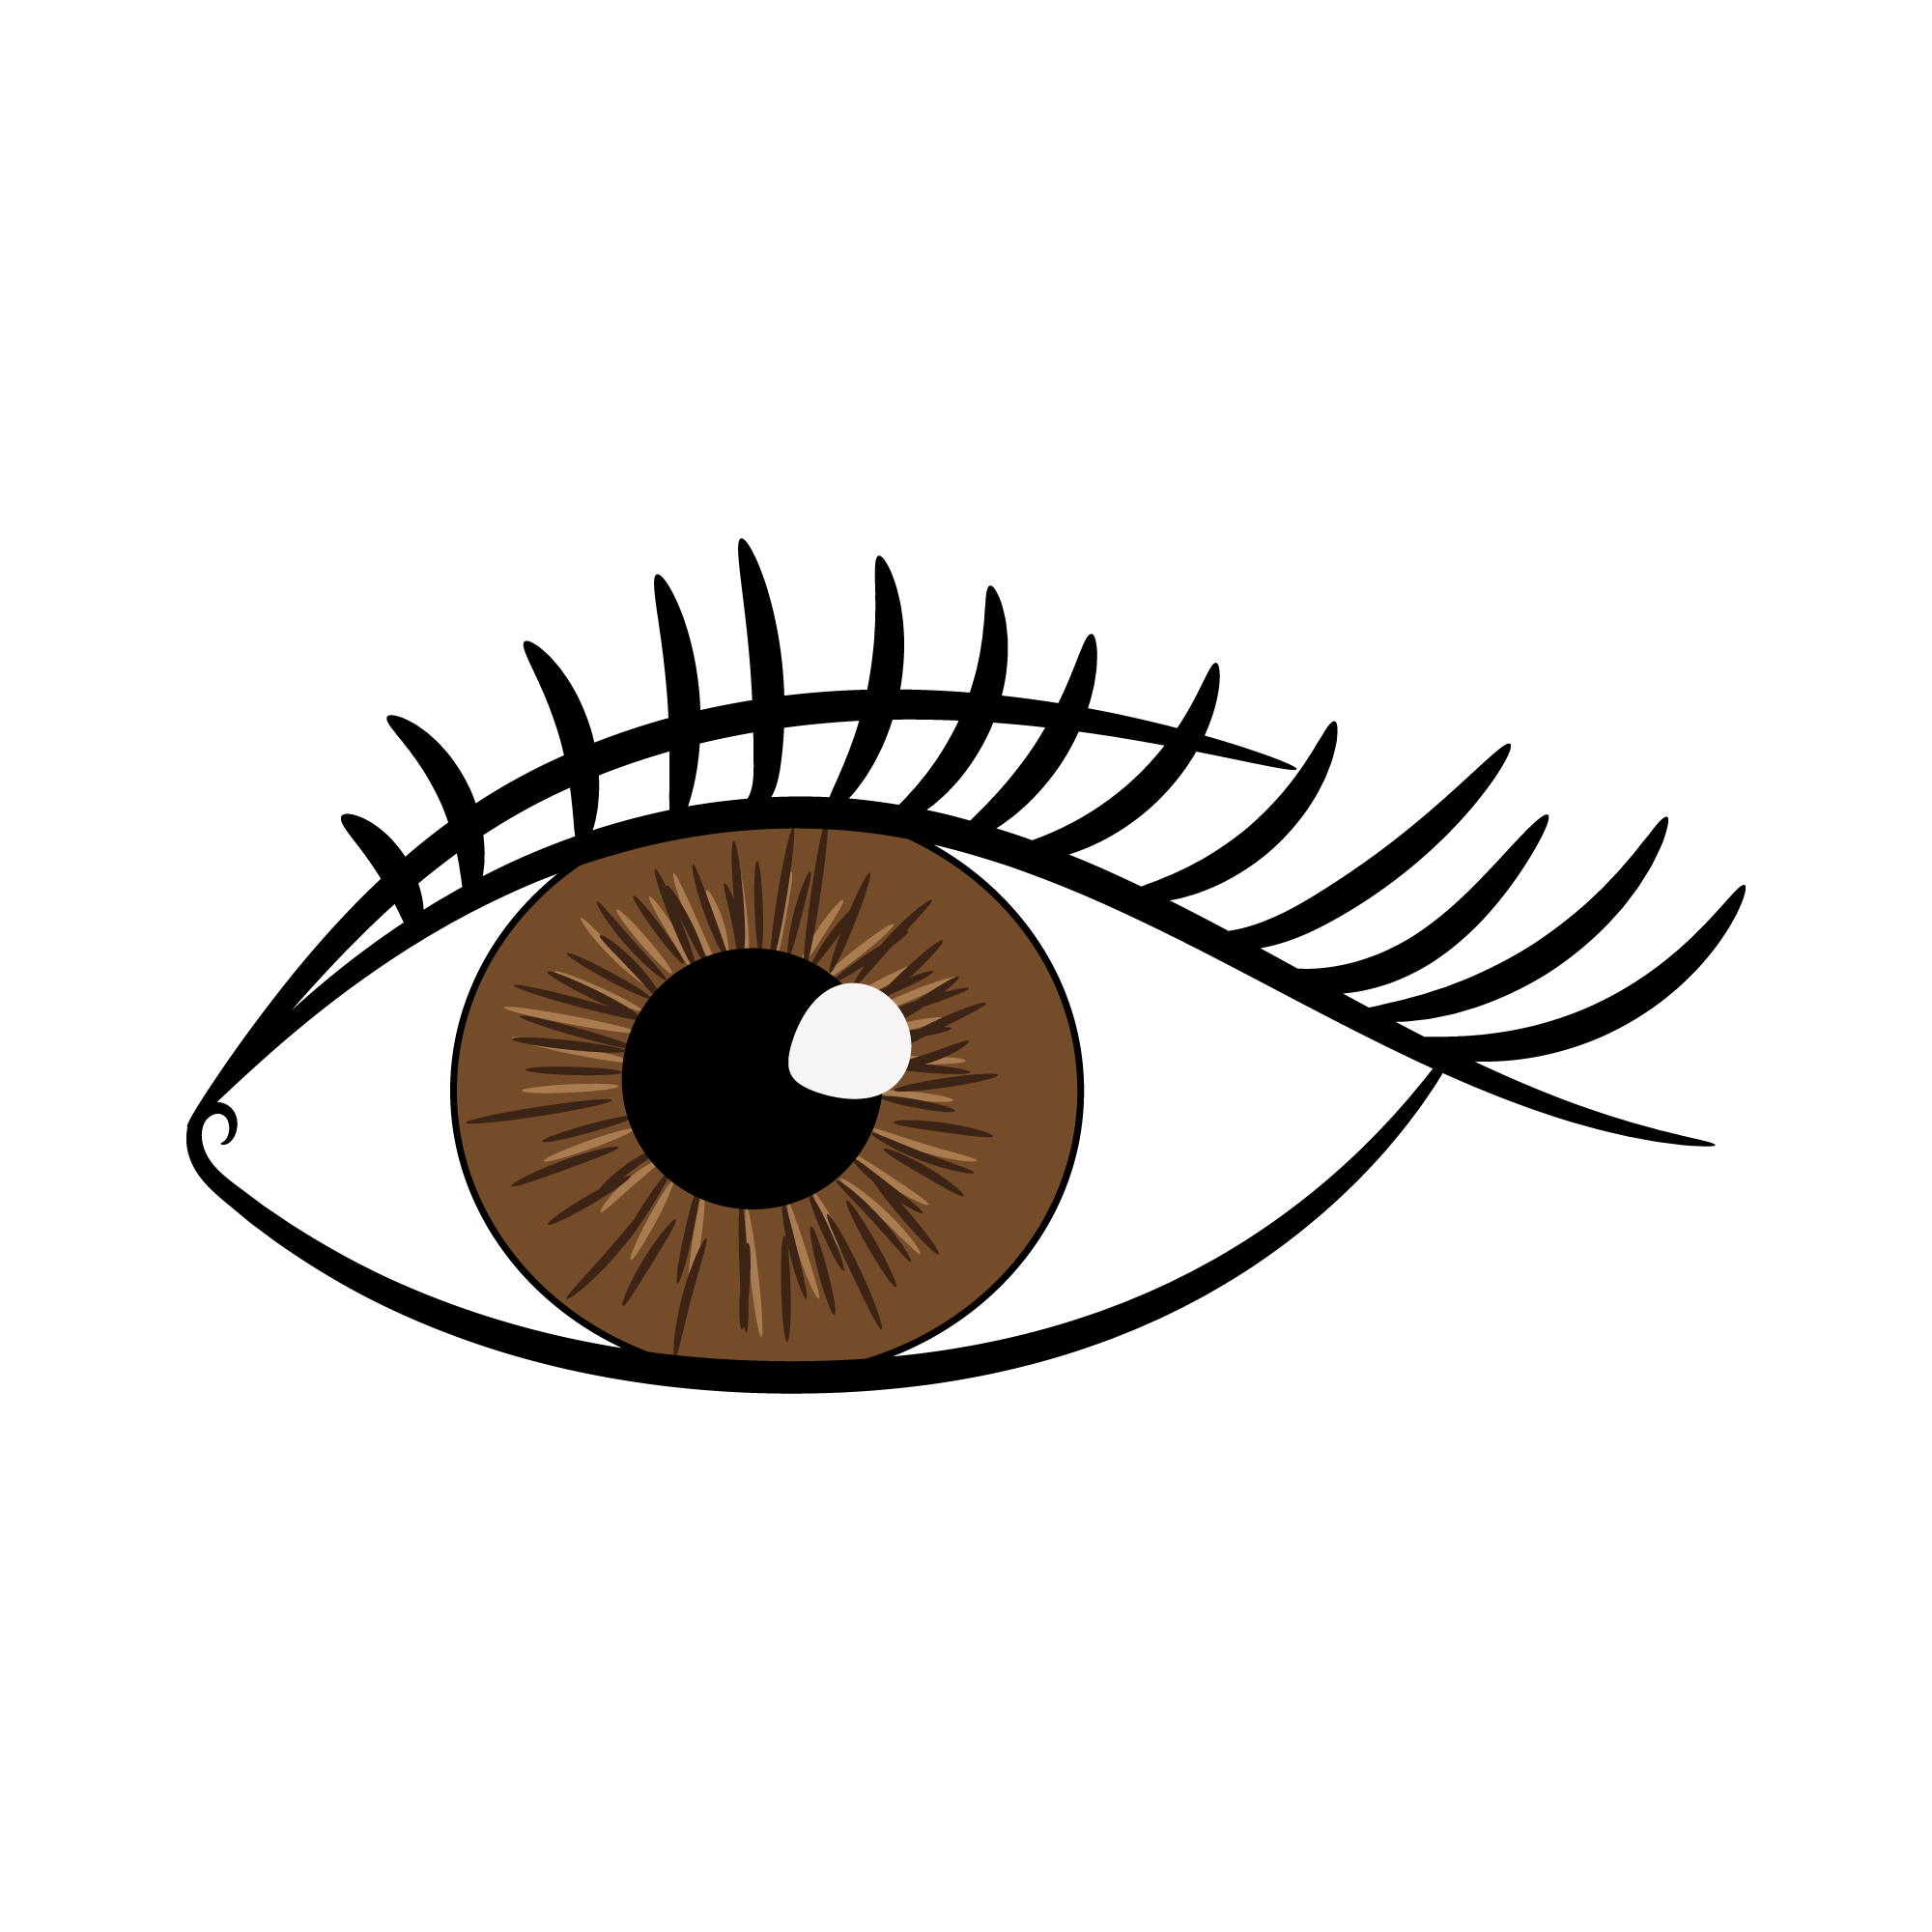

We’ve all got brown hair. We have all got brown eyes.
Svi u mojoj obitelji imaju smeđu kosu . Svi u mojoj obitelji imaju smeđe oči.

We are friendly and creative.
Mi smo druželjubivi i kreativni.

- 2
a) Read the sentences from task 1 again.
Pročitaj rečenice iz 1. zadatka još jednom.
b) Fill in the table about the boy and his family.
Ispuni tablicu o dječaku i njegovoj obitelji.
c) Use the words in the frames.
Upotrijebi riječi iz okvira.

Xavi

mum, dad, two sisters and Xavi

11

Xavi's family
Name  Ime | Xavi
Age
Godine
People in the photo
Ljudi na fotografiji

- 3 Look at the pictures.
Pogledaj slike.
Who is in the photos?
Tko je na slikama?
Describe them.
Opiši ih.
What do they look like?
Kako izgledaju?
What are they like?
Kako se ponašaju?

Be careful.
What am l like?
Kako se ponašam?

I am happy.
Sretan sam.
I am friendly.
Volim se družiti.
I am creative.
Kreativan sam.
Budi oprezan / oprezna.
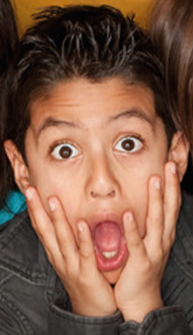

What do I look like?
Kako izgledam?

I have got short brown hair.
Imam kratku smeđu kosu.
I have got brown eyes.
Imam smeđe oči.

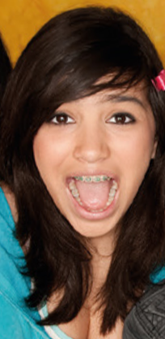

Xavi's sister has got ____________________.
Xavijeva sestra ima smeđu kosu.
Xavi's sister is __________________
Xavijeva sestra je kreativna.

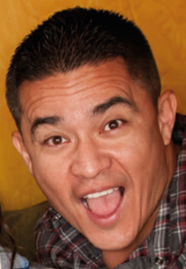
Xavi's dad has got ______________________.
Xavijev tata ima smeđe oči.
Xavi's dad is __________________________.
Xavijev tata je druželjubiv.

- 4 Look at the picture. Read the sentences.
Prouči sliku. Pročitaj rečenice.

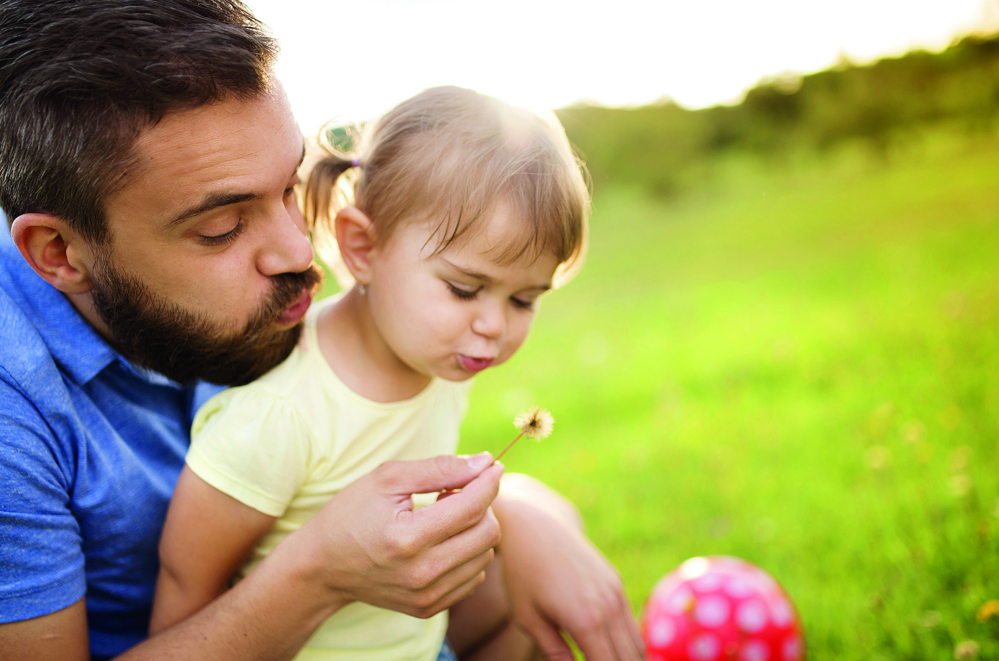
My name is Riley. This is my family.
Zovem se Riley. Ovo je moja obitelj.

3

This is me. I am 3 years old.
Ovo sam ja. Imam 3 godine.


SHORT
I am short.
Ja sam niska.

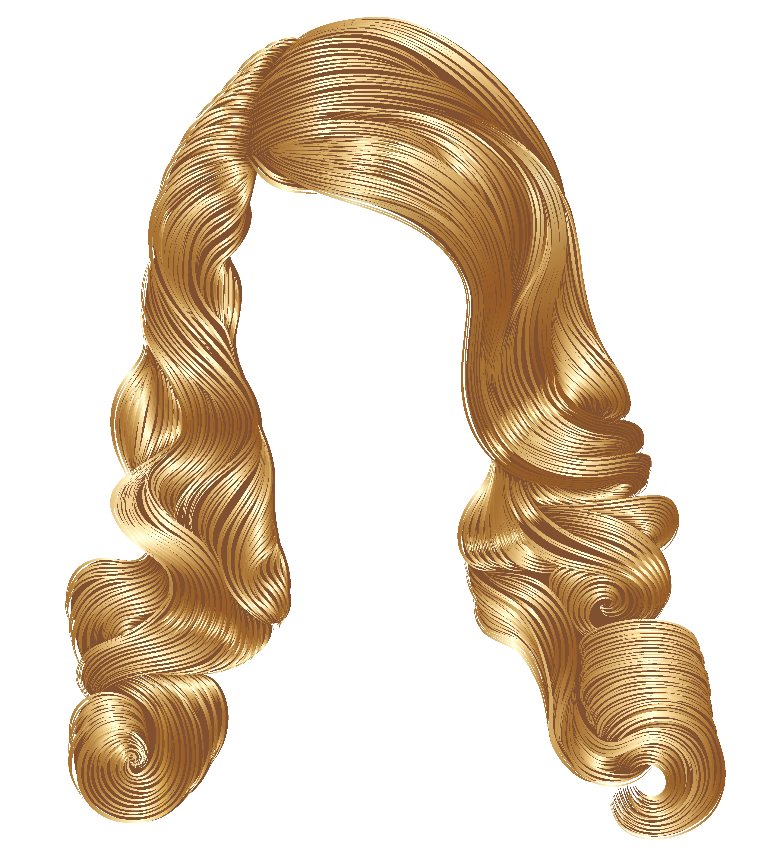

I have got blond hair. I have got brown eyes
Imam plavu kosu. Imam smeđe oči.


I am happy.
Sretna sam.

This is my dad.
Ovo je moj tata.
TALL

He is tall.
On je visok.

He has got brown hair and brown eyes.
On ima smeđu kosu i smeđe oči.



He is smart.
On je pametan.

- 5
a) Read the sentences from task 3 again.
Pročitaj rečenice iz 3. zadatka još jednom.
b) Fill in the table about the girl and her family.
Ispuni tablicu o djevojčici i njezinoj obitelji.
c) Use the words in the frames.
Upotrijebi riječi iz okvira.
Riley

dad and Riley

3

Riley's family
Name  Ime | Riley
Age
Godine
People in the photo
Ljudi na fotografiji

- 6 Look at the pictures.
Pogledaj slike.
Who is in the photos? Describe them.
Tko je na slikama? Opiši ih.
What do they look like?
Kako izgledaju?
What are they like?
Kako se ponašaju?

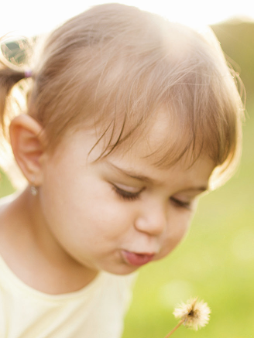

Riley is ________________________________ .
Riley je niska.
Riley has got ___________________________ .
Riley ima plavu kosu.
Riley is _______________________________ .
Riley je vesela.

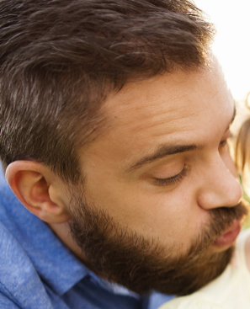

Riley's dad is __________________________ .
Rileyin tata je visok.
Riley' s da has got __________________
.
Rileyin tata ima smeđu kosu i smeđe oči.

Riley's dad is _________________________ .
Rileyin tata je pametan.

- 7 Sort out the words into two columns.
Rasporedi ove riječi u stupce.
Use pictures to help you.
Slike će ti pomoći.

brown eyes happy

blond hair smart

tall short

What are they like?  Kakvi su? | What do they look like?  Kako izgledaju?
happy,

- 8 Describe your family members.
Opiši svoju obitelj.
What do they look like?
Kako izgledaju članovi tvoje obitelji?
What are they like?
Kako se ponašaju članovi tvoje obitelji?

a) Glue a photo of your family in the frame.
Nalijepi sliku svoje obitelj u okvir.

b) Complete the sentences about your family.
Dovrši rečenice o članovima svoje obitelji.

My mum has got ________________________ .
(Moja mama ima…)
My mum is _____________________________ .
(Moja mama je…)
My dad has got _________________________ .
(Moj tata ima…)
My dad is ______________________________ .
(Moj tata je…)

My sister has got ________________________ .
(Moja sestra ima…)
My sister is ____________________________ .
(Moja sestra je…)
My brother has got ______________________ .
(Moj brat ima…)
My brother is ___________________________ .
(Moj brat je…)
My ____________________________________ .
(Moj / Moja…)
My ____________________________________ .
(Moj / Moja…)

